Analysis of the Functions of the Network Layer

• Summarize the main purpose of the layer and explain what services it can provide.
总结该层的主要功能，并解释它能够提供哪些服务。
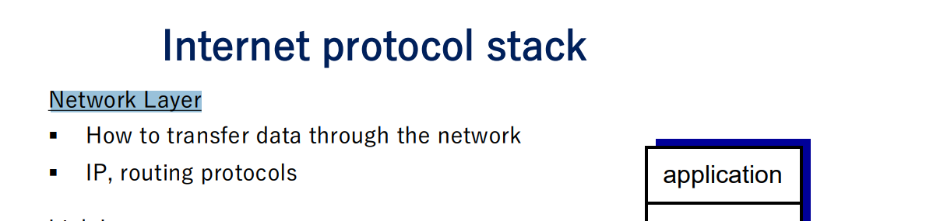
The purpose of network layer is to transport the segment from sending host to receiving host

• Describe some of the main protocols that operate on this layer in detail.
详细描述运行在该层的一些主要协议。
• Explain how the layer interacts with and uses protocols and services of the upper and lower layers.
解释该层如何与上下层的协议和服务进行交互并加以利用。

